**ES5**

**ARRAYS METHODS:**

1. **Is Array ():**

function myFunction() {

var fruits = ["Banana", "Orange", "Apple", "Mango"];

console.log(Array.isArray(fruits));

}

myFunction();

**OUTPUT:**

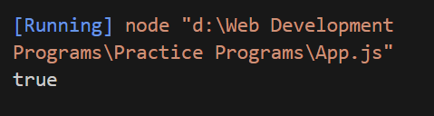

1. **Array every ():**

//example1

var arr=[50,100,150,200,250,300];

var us=arr.every(

function(teja){

return teja<400;

}

)

console.log(us);

//example2

var arr=[50,100,150,200,250,300];

var el=arr.every(

function(teja){

return teja<250;

}

)

console.log(el);

**OUTPUT:**

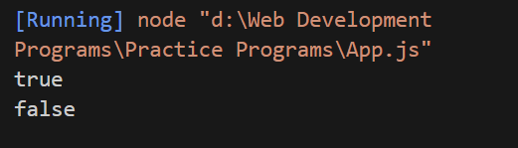

1. **Filter Array:**

var data=[25,10,75,10,125];

var user=data.filter(

function(element){

return element<80;

}

)

console.log(user);

**OUTPUT:**

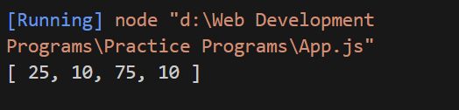

1. **For Each Array:**

//example1

var data=["Teja ","Gowtham","Ashok","Harsh","Jhosh","Sai","Ganesh"];

data.forEach(

function (a){

console.log(a);

}

)

//example2

var usr=[1,2,3,4,5];

usr.forEach(

function(ele){

console.log(ele);

}

)

**OUTPUT:**

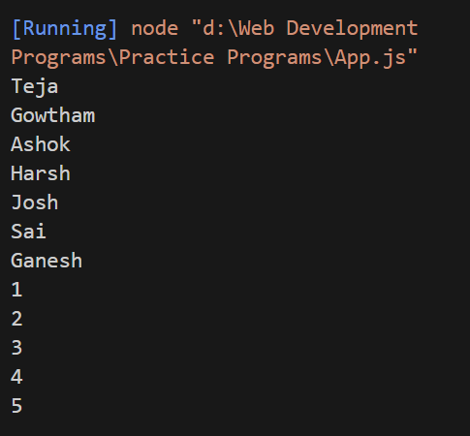

1. **Index Of Array:**

//example1

var data=[5,10,15,20,25,30];

console.log(data.indexOf(25));

//example2

var a=[1,2,3,4,5,2,9,10];

console.log(a.indexOf(9));

//example3

var b=["Teja","Gowtham","Ashok","Sai"];

console.log(b.indexOf("Teja"));

**OUTPUT:**

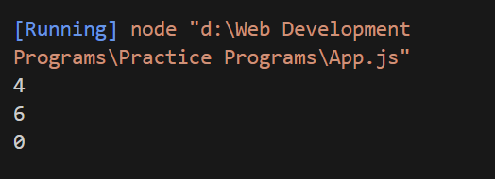

1. **Last Index Of Array:**

//example1

var data=[5,7,10,4,7,20,7,5,70];

console.log(data.lastIndexOf(7));

//example2

var a=[1,2,3,4,6,3,5,7,8];

console.log(a.lastIndexOf(3));

//example3

var b=["Teja","Gowtham","Ashok","Pavan","Sai","Hari"];

console.log(b.lastIndexOf("Sai"));

**OUTPUT:**

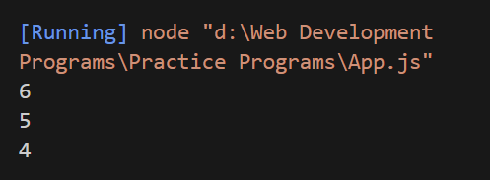

1. **Map Array:**

//example1

var data=[2,4,6,8];

var user=data.map(

function(element){

return element*10;

}

)

console.log(user);

//example2

var arr=[50,100,150,200,250,300];

var usr=arr.map(

function(ele){

return ele/10;

}

)

console.log(usr);

**OUTPUT:**

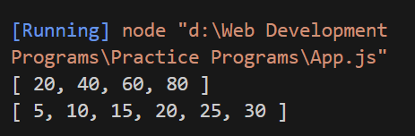

1. **Some Array:**

//example1

var data=[10,20,30,40,50];

var usr=data.some(

function(element){

return element<40;

}

)

console.log(usr);

//example2

var data=[10,20,30,40,50];

var ele=data.some(

function(abc){

return abc>60;

}

)

console.log(ele);

**OUTPUT:**

